Thermal Couple Measurement

TC1 (average: roughly: 35.5 degC)

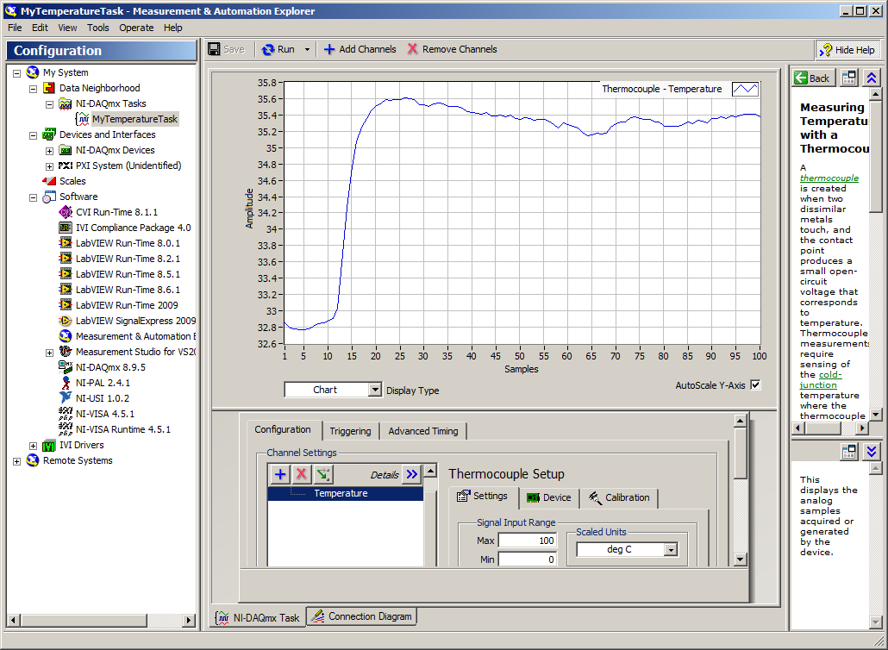

TC TC1

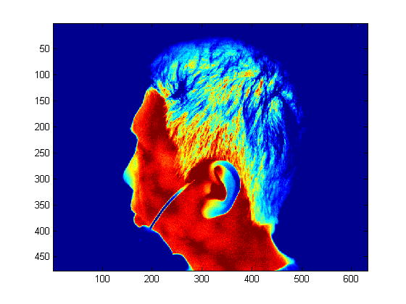 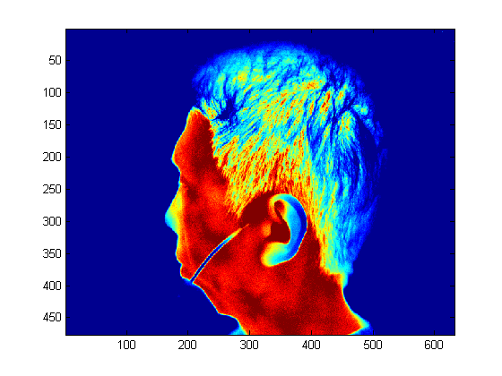

After shifting: make the value measured at (304,297) close to 35.5degC 🡪 deduct 12 degC from all values in the image TC1

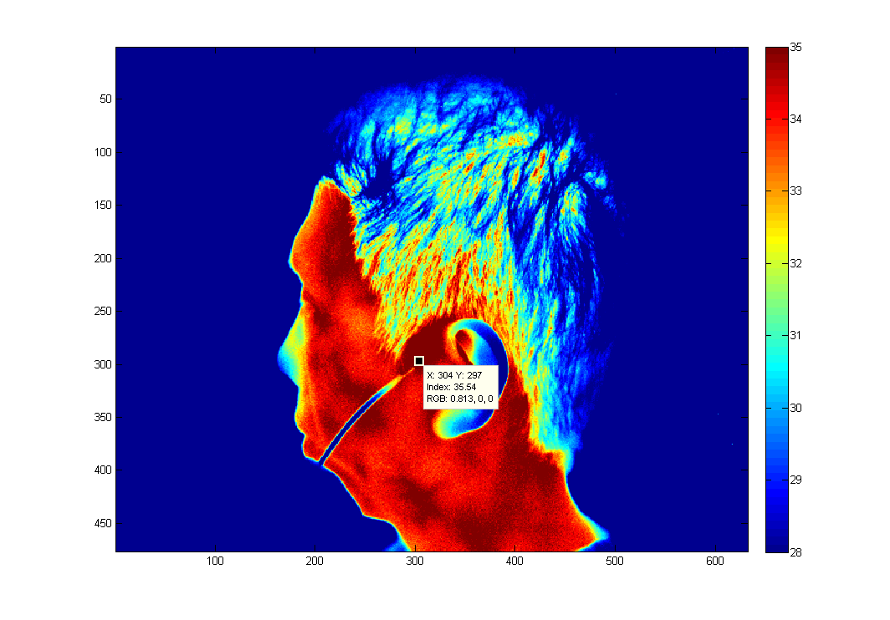

TC2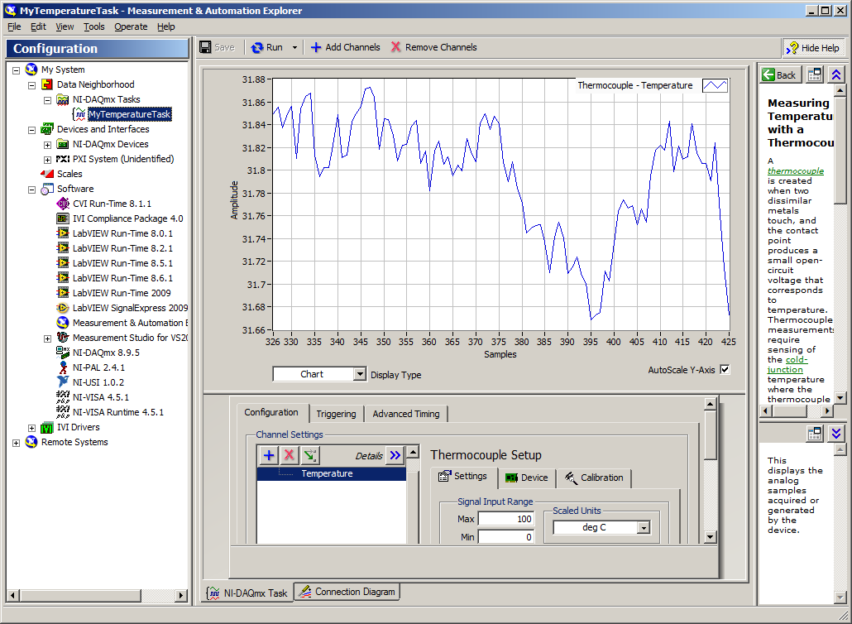

TC3

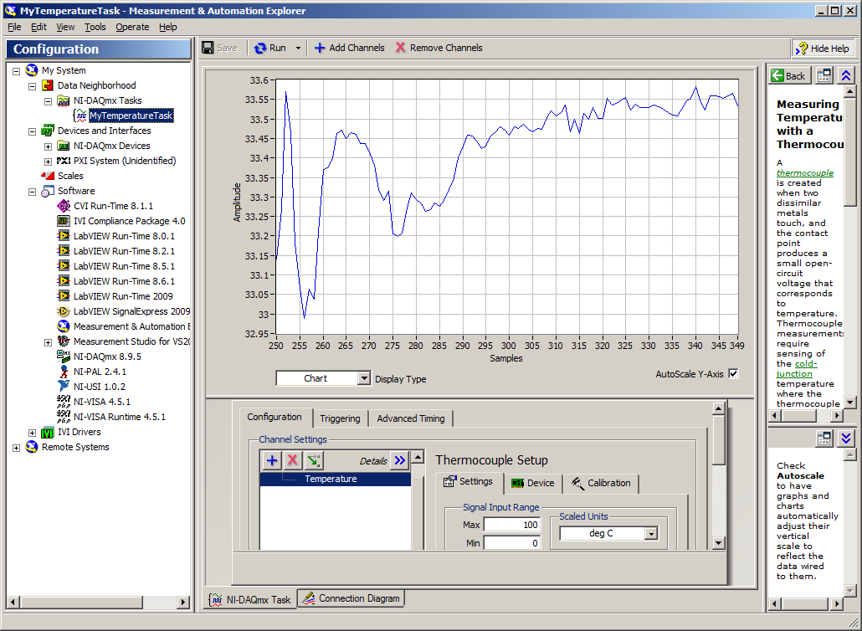

TC3

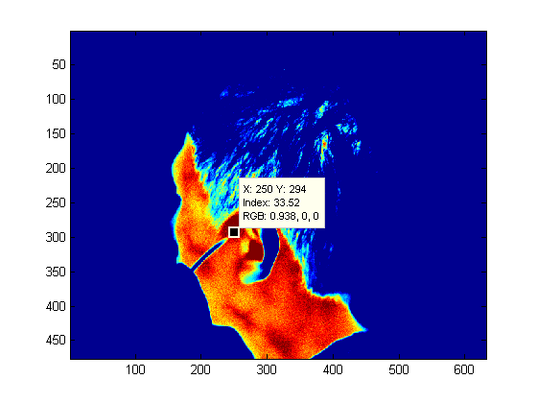 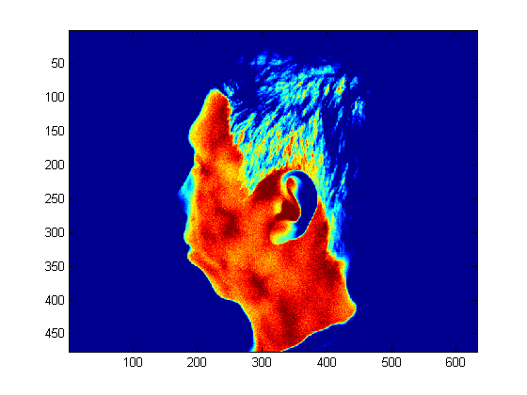

After shifting: make the value measured at (250,294) close to 33.52degC 🡪 deduct 13.5 degC from all values in the image TC3